Installation and usage of prototype

FTS group 2: Future of neighbourhoods

Table of contents

Installation 2

Prerequisites 2

Installing Python 2

OpenAI account 2

Configuring the prototype 3

API key 3

Running the prototype 6

Using the prototype 9

Settings page 10

# Installation

In the included media drive a folder named “FTS Prototype” will be present. Inside this folder is a folder name “project” containing all the project files and a folder named “python installer” which contains the python installer.

## Prerequisites

To install the prototype there are two main prerequisites. These prerequisites are:

* Python (3.12)
* OpenAI account (with active credit)

### Installing Python

To install Python, you can use the included installer within the project files under the folder labelled “python installer”.

Alternatively, Python can be downloaded from the official website:

[https://www.python.org/downloads/](https://www.python.org/downloads/windows/)

Note that the project was built using Python 3.12 and requires this specific version to ensure compatibility.

When Installing Python make sure that “add to PATH” is selected on the first screen. Then “Install now” can be selected.

### OpenAI account

An OpenAI account is used by the prototype to facilitate the chatbot functionality.

An account can be created on their official website:

<https://chat.openai.com/auth/login>

For the prototype to function the account does need to have an active balance to be able to pay for the server usage.

To add funds to an OpenAI account you can visit their platform website by using the following link once you are logged in:

<https://platform.openai.com/account/billing/overview>

## Configuring the prototype

Included in the ‘FTS Prototype’ folder is a folder labelled “project”. This “project” folder contains the actual prototype. Copy the “project” folder to an installation destination of preference (for example the desktop).

There is only one thing we will have to configure before we can run the project. We need to specify an API key. With this key the project can use the OpenAI account to function.

### API key

For the prototype to function it needs a connection to the specific account. We can accomplish this by generating an API key using your account. This key should only be used for the prototype since anyone with this key can use the associated account and thus use funds.

To create a new **API key**, you visit the platform website using the following link:

<https://platform.openai.com/api-keys>

Now you will have to give the key a name.

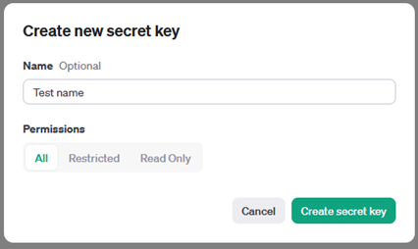

Now the key will have been generated.

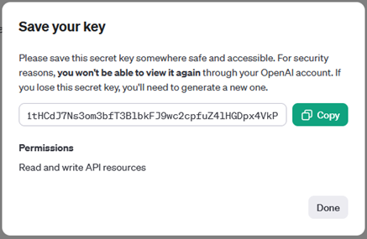

Now we must copy this key and place it within a file in the project folder. This file is named **“.env”** like so:

Replace the *‘your_secret_key_here’* text with your newly generated API key. It sould look like this:

Note that the quotation marks are not present!

### Running the prototype

Now that the API key is configured, we can move on to running the prototype. Within the project folder is a file named **“startscript.bat”**

If all is well the only step left will be to simply double click on this file. This will run the project and install additional required modules for the project to function. The installation of these extra modules only requires extra time the *first* time you run this file. Subsequent runs should not take as long.

Congratulations the prototype is not working!

To stop the prototype you can simply *close the widow* or press *CTRL+C* when the window is highlighted.

To verify this you can open a webbrowser and type this in the search bar:

<http://127.0.0.1:5000>

# Using the prototype

There are two ways to use the prototype. You can either talk in the microphone or you can type out your message. Both methods require pressing the enter key or clicking on the arrow button to send the message.

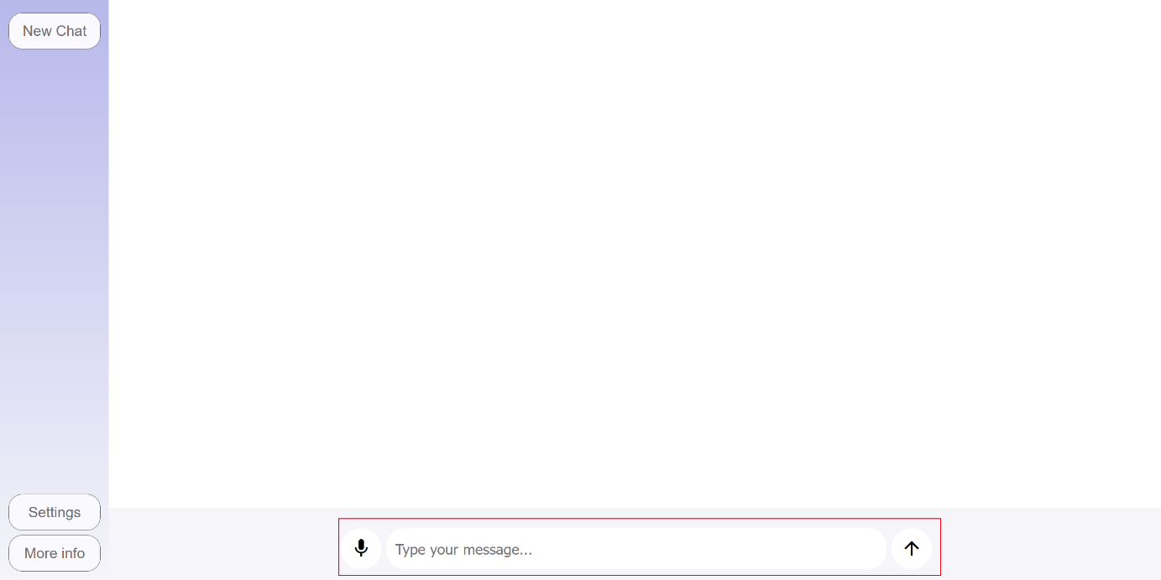

## Settings page

In the settings page it is possible to add events to the prototype. The interface is a bit crude, but it works functionally.

Settings page:

Here you can add events to the database of the prototype. This changes only the local database and not the database used by the assistant. To update the database of the assistant you only must click on the *‘update assistant database’* button on the right side of the screen. This will upload the local database to the assistant.